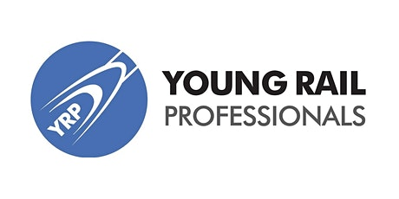
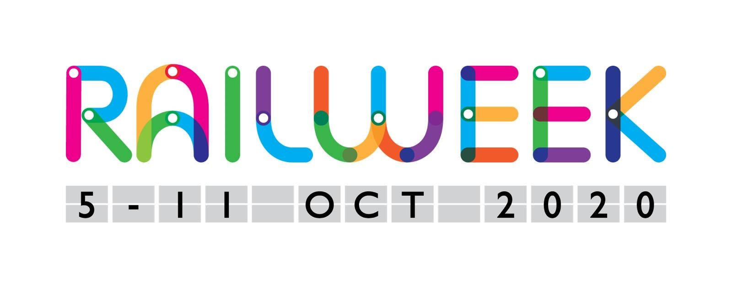
Rail Week 2020 Pledge Letter
Pledge your support to transform a generation
Dear Rail Week Team,
Rail Week is a fantastic idea and we at ______________________ (your company name) would love to take part and help to attract the next generation of young people into rail careers.
In support of Rail Week we aim to (check all that apply):
☐ Organise ____ events at our facilities
☐ Volunteer ___ staff as Young Rail Ambassadors for Rail Week
☐ Contact ___ local schools and colleges to engage with them during Rail Week
☐ Promote our involvement in Rail Week via news and social media
☐ Reach out into the local community to celebrate the rail industry in the region
So that we can work with you, here are the details of some people you can contact within our company to help maximise our involvement in Rail Week:
Name | Role | Email | Mobile
N.B. This could include Primary Point of Contact, Comms Manager, Events Coordinator, Entry-level talent manager, PR Manager.
We are excited to help make Rail Week 2019 a success and if you require any additional support don’t hesitate to ask.
Best regards,
Signed (director): __________________ Name: __________________

Please return completed pledge to railweek-enquiries@youngrailpro.com

